PHP Tutorials

Yelyn Yoo

Example 1

<http://students.cs.ndsu.nodak.edu/~yelyn.yoo/writefile.php>

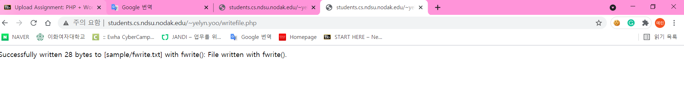

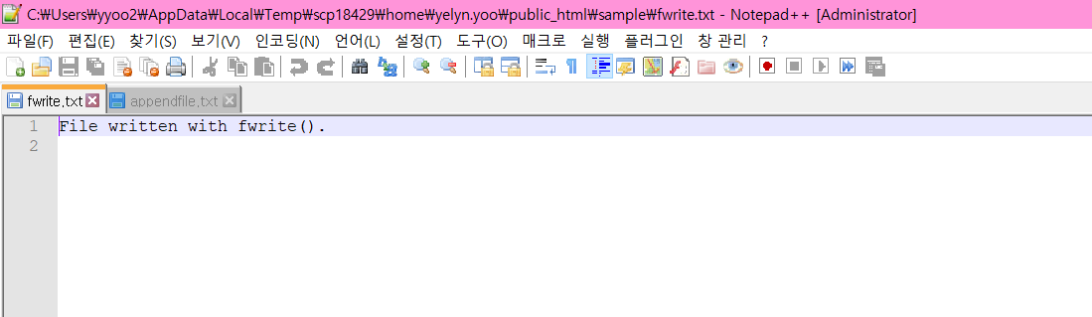

Example2

<http://students.cs.ndsu.nodak.edu/~yelyn.yoo/writeappend.php>

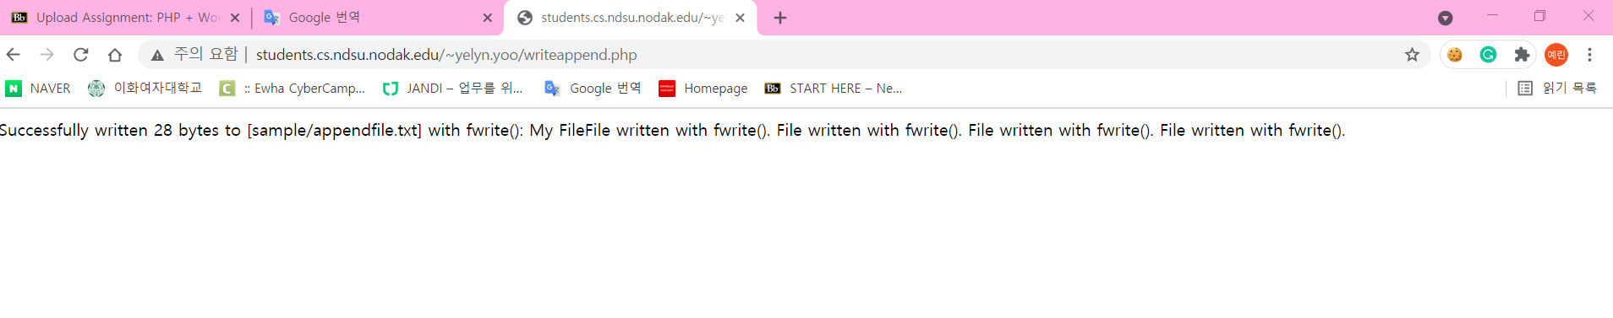

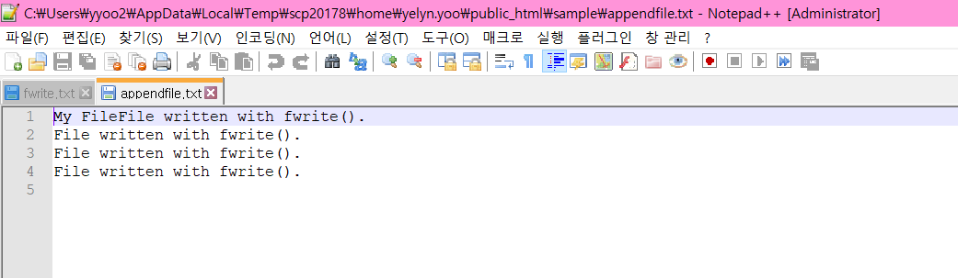

Example3

<http://students.cs.ndsu.nodak.edu/~yelyn.yoo/getdata.php>

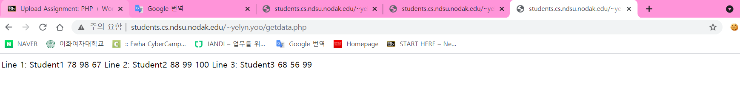

## Reading CSV Files

<http://students.cs.ndsu.nodak.edu/~yelyn.yoo/fgetcsv.php>

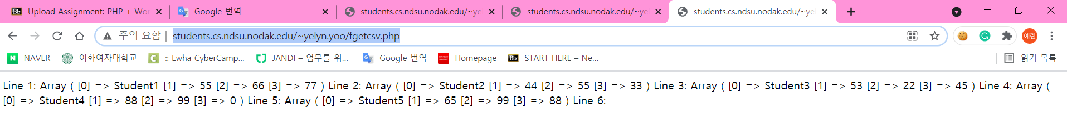

Example4

<http://students.cs.ndsu.nodak.edu/~yelyn.yoo/download.php>

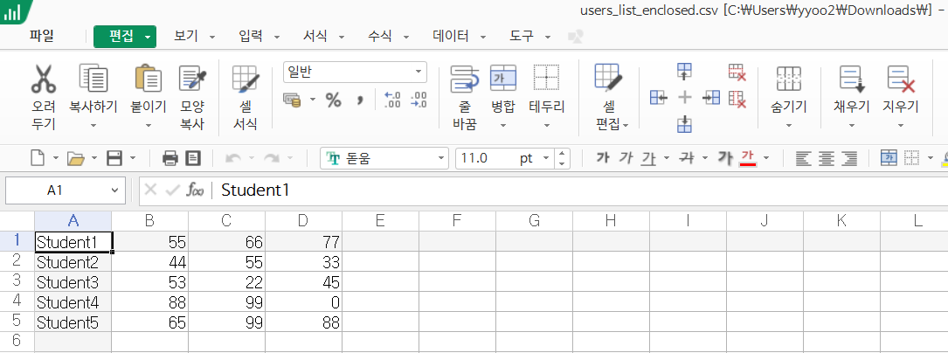

Example5

<http://students.cs.ndsu.nodak.edu/~yelyn.yoo/delete.php>

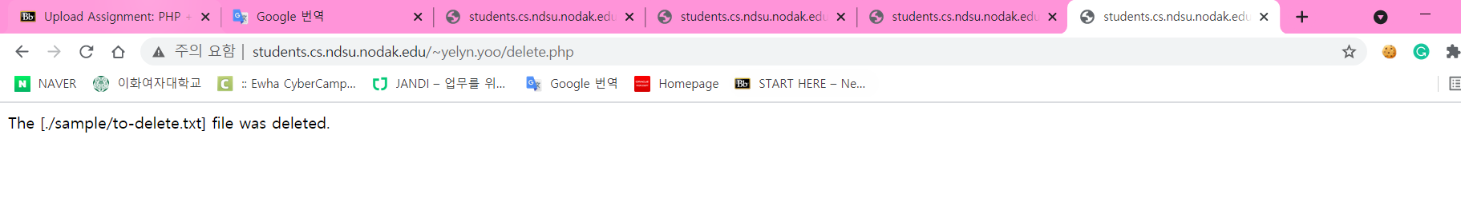

Example6

<http://students.cs.ndsu.nodak.edu/~yelyn.yoo/registration.html>

